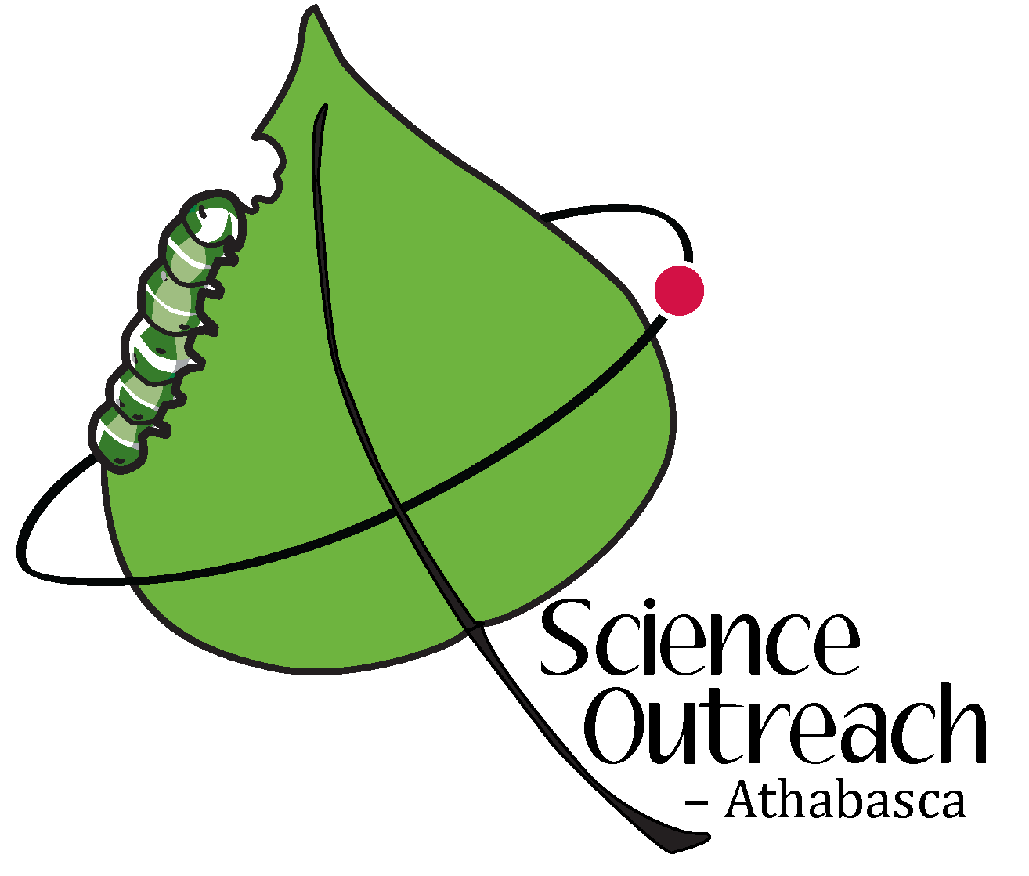
Science Outreach – Athabasca presents…
Mollusks: snails, clams and squids

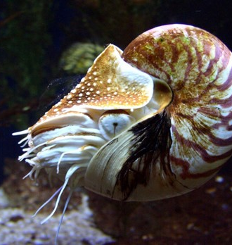
Speaker: Robert Holmberg,
Professor Emeritus, Biology, Athabasca University
Date: Monday, August 21, 2023

Time: 1:30 PM

Place: Rochester Library

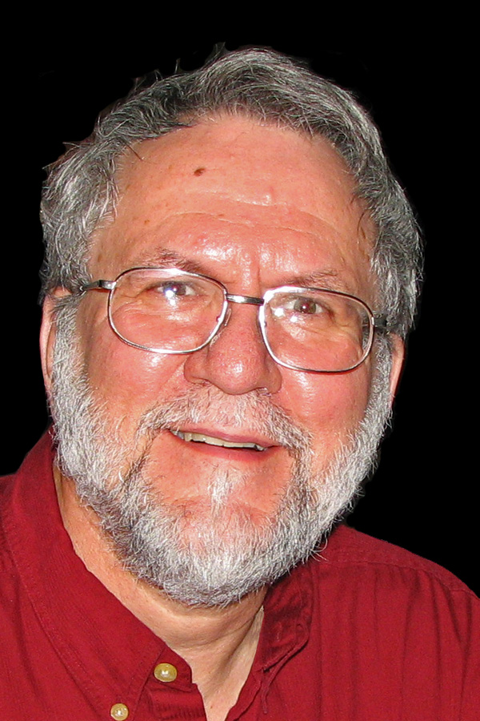
Mollusks are soft-bodied animals, but often with shells, that mainly inhabit the oceans. However, even in land-locked areas, such as Alberta, there are some interesting native mollusks. Moreover, we find many mollusks in our grocery stores as well as in various jewelry and other decorative objects. This talk will open up the world of mollusks. Come and learn about the second most diverse group of animals in the world. Robert Holmberg is a founding member of Science Outreach – Athabasca and an invertebrate zoologist, who is an Emeritus Professor at Athabasca University.

Please feel free to visit our YouTube Channel
or go to
Science Outreach - Athabasca website

Follow us on Twitter: @SciOutrAthab
Like us on Facebook: https://www.facebook.com/scienceoutreachAU/ Visit: http://scienceoutreach.ab.ca/

*** Any changes will be posted on our website.***

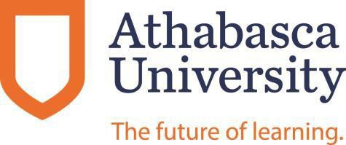

Science Outreach – Athabasca supported by

